1.41:
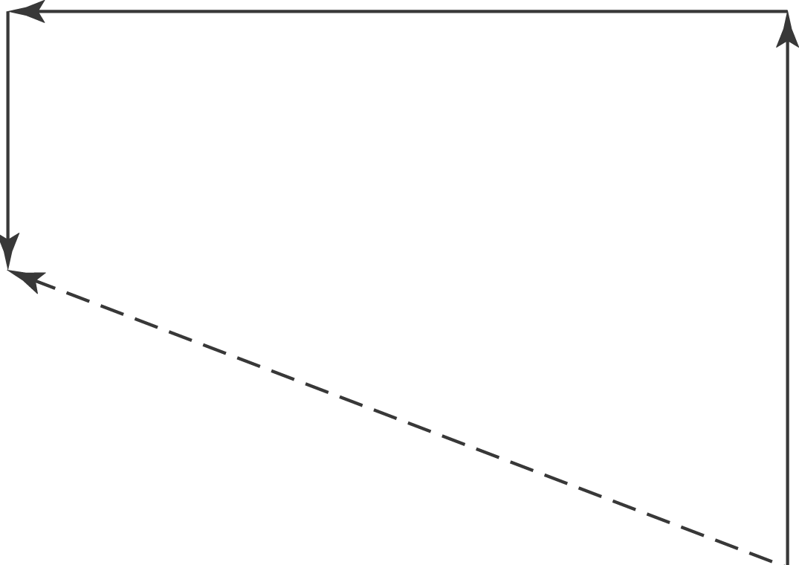

The total northward displacement is 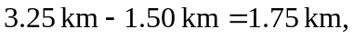, and the total westward displacement is 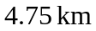. The magnitude of the net displacement is 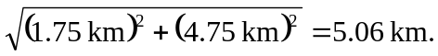 The south and west displacements are the same, so The direction of the net displacement is 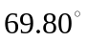West of North.

